Table of Contents
Table of Contents 1
Table of Figures 2
PROJECT TITLE 3
PROJECT DETAILS 3
INTRODUCTION 3
Overview 5
Data collection:- 6
Data Processing 8
Machine learning 8
Machine learning algorithms 8
K-Nearest Neighbors 8
K-Neighbors classification 8
K-neighbors regression 10
Linear Models 10
Linear regression 11
Ridge regression 11
Linear models for classification 12
Decision Trees 12
Random forests 14
Support vector machines 15
Model Evaluation 16
Regression Model Evaluation 16
Classification model evaluation 16
Literature survey 18
Vehicle health characteristics 18
Driving characteristics 21
Pothole and speed breaker detection 25
References 30
Appendix A 31

Table of Figures
Figure 1 Block diagram of the process 6
Figure 2 OBD adapter and OBD II port 7
Figure 3 mobile camera as photo detection camera 7
Figure 4 Predictions made by the one-nearest-neighbor model on the forge dataset 9
Figure 5 Predictions made by the three-nearest-neighbors model on the forge dataset 9
Figure 6 Predictions made by one-nearest-neighbor regression on the wave dataset 10
Figure 7 Predictions of a linear model on the wave dataset 11
Figure 8 Decision boundaries of a linear SVM and logistic regression with default parameters 12
Figure 9 A decision tree to distinguish among several animals 12
Figure 10 Decision boundary of tree with depth 1, 2, 9 13
Figure 11 Decision boundaries found by five randomized decision trees and the decision boundary obtained by averaging their predicted probabilities 14
Figure 12 Decision boundary found by a linear SVM 15
Figure 13 Expansion of the dataset, created by adding a third feature derived from feature 1 and Decision boundary found by a linear SVM on the expanded three dimensional dataset 15
Figure 14 VMMS Architecture 19
Figure 15 Generic data driven FDD approach 20
Figure 16 gas pedal angle signal and its difference quotient, mean, median, and standard deviation. 22
Figure 17 Speed and acceleration plot over time 23
Figure 18 Table showing the driving characteristics 23
Figure 19 Principal Component Analysis on dataset 24
Figure 20 Interpretation by principal components and by rotated components 24
Figure 21 Ultrasonic sensor and receive-transmit operation 25
Figure 22 Flowchart for pothole detection 26
Figure 23 Flow chart for speed breaker detection 27
Figure 24 complete flowchart of detection 27
Figure 25 Location of potholes plotted in map [6] 28
Figure 26 System model of deepbus [7] 28
Figure 27 Performance comparison of various machine learning algorithms [7] 29
Figure 28 Flowchart of data acquisition 30
Figure 29 Flowchart of low-computational data-based trigger. 31
Figure 30 Flowchart of high-computational image-based trigger 32
Figure 31 Pothole validation through accelerometer data 32
Figure 32 Accelerator pedal position and vehicle speed through potholes 33
Figure 33 Image processing system 34
Figure 34 Pothole detection algorithms 36

PROJECT TITLE
- Scalable Machine learning and analytics of vehicle data to derive vehicle health and driving characteristics.
- Key words : Machine learning, Vehicle data, IOT

PROJECT DETAILS
- AIM
- The project aims at working on diagnostics stack access the various engine parameters and onboard diagnostic protocol. Using data to build a machine learning framework for vehicle and driver characteristics. Further the development towards a scalable method for multiple vehicles.

INTRODUCTION
In India, it is observed that more than 50% of the accidents occur due to bad road conditions. Road anomalies such as potholes and roughness also add up to traffic congestion in major cities. To solve such issues, it is important to monitor the condition of roads and vehicles regularly.
Vehicles having very complex structure need an effective maintenance strategy. Three types of maintenance strategies are being used in vehicle industry, predictive maintenance, corrective maintenance, and preventive maintenance. In predictive maintenance, current condition of system/vehicle is analyzed to predict what is probably going to fail.
The characterization of driving behavior is not only crucial for accident prevention, as most of car accidents are due to human mishandling , but it is also important for designing driving models, which are the core of algorithms that might make the future of self-driving cars possible. Also, we can provide image processing in vehicle that will detect road signs such as speed limits, pedestrian or animal cross boards, roadwork indications, overhead warning boards, direction boards, railway tracks, etc., need to be detected in taking a decision on changing the direction and speed of the moving vehicle. This will help in self driving vehicles.

We can sort these issues into two categories:
- Road anomalies
- Driver and Vehicle behavior
Road anomalies can include potholes, speed-breakers or just any other abnormality on roads.
An efficient method to detect such anomalies can be through an accelerometer. An accelerometer is a device used to measure acceleration forces in the x y and z directions. Most of the smartphones today have an accelerometer in-built. This makes our approach cost efficient as we do not require any additional hardware.
The idea is to measure acceleration in x y and z directions and recognize peaks in order to detect harsh movement of the vehicle. But how do we measure the acceleration forces? How do we visualize them?
Smartphones have applications that can be installed onto the devices that measure and display acceleration forces on a 3D plane. But is measuring acceleration enough? What can we do with that information?
Accelerometer data combined with driving style analysis or drive cycles can be of great benefit. OBD (On board diagnostics) is a simple port attachable device that records real time data from cars such as RPM, Fuel data, Pedal positions, location coordinates and much more. This data can be correlated with the accelerometer data to render amazing analytic models. The huge collection of data acquired can help us understand how the anomalies affect automobiles and how drivers react to such anomalies.

Overview
- We can perform predictive maintenance analysis of vehicle based on acceleration data we will get either through OBD2 sensor or mobile app. We will perform the FFT analysis then afterwards using ML algorithm we can classify whether the vibration data is normal or abnormal.
- Pothole and speed breaker detection, by detecting them diver can be alarmed and he can reduce speed of vehicle. The same can be achieved for the autonomous driving, so the car will automatically slow down or change direction. By detecting potholes at any positon we can mark that position and send information to municipality.
- Road sign detection. By the help of image processing we can detect road signs such as speed limits, pedestrian or animal cross boards, roadwork indications, overhead warning boards, direction boards, railway tracks, etc., need to be detected in taking a decision on changing the direction and speed of the moving vehicle.
- Driving behavior detection, with the help of speed, rpm, engine load, acceleration data, acceleration pedal positon data we can detect driving behavior of driver. Now this can be used for giving driving license to person who is learning driving. So after some driving period person’s driving behavior will be analyzed and license will be granted to that person.
- Another driving behavior is to rank the driver to qualify him for bus driver/ school bus driver/ Ola, Uber driver.

General procedure we will follow is collect data from sensor. Store the data and apply our machine learning algorithm on it. Our machine algorithm will give the result we want, whether it is about vehicle health detection, pothole/speed breaker detection, driving behavior classification, etc.
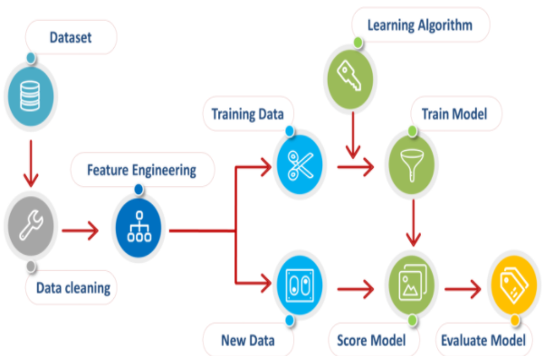
Figure 1 Block diagram of the process

Data collection:-
The idea is to measure acceleration in x, y and z directions and recognize peaks in order to detect harsh movement of the vehicle. This can be measured with the help of in built app in phone and it will record acceleration data while driving. Accelerometer data combined with driving style analysis or drive cycles can be of great benefit.
OBD (On board diagnostics) is a simple port attachable device that records real time data from cars such as RPM, Fuel data, Pedal positions, location coordinates and much more. This data can be correlated with the accelerometer data to render amazing analytic models. The huge collection of data acquired can help us understand how the anomalies affect automobiles and how drivers react to such anomalies.
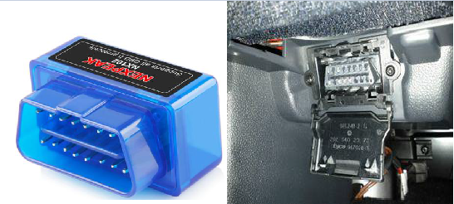
Figure 2 OBD adapter and OBD II port

Torque Pro is one of the most popular apps for reading the OBDII data.
It has both diagnosis capabilities (reading the error codes, system checkup, resetting error codes etc.) as well as real-time dashboard and graphing capabilities.
Connect to it with Bluetooth pairing and select list of sensors that we are going to need for our analysis.
For pothole/ speed breaker, road sign detection we can use mobile phone camera, no need to add extra setup to make our setup low cost.
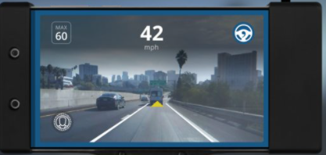
Figure 3 mobile camera as photo detection camera

Data Processing
Data processing means extracting data from dataset based on our application.
If we want to determine vehicle health characteristics then data related to such as acceleration in x, y and z, engine rpm, engine load. Similarly for the driving behavior classification along with acceleration data we also want pedal position, location, etc.
Once our data is ready after processing, it is time to send to machine learning algorithm to perform next task.

Machine learning
Machine Learning (ML) is a branch of artificial intelligence based on the idea that systems can learn from data, identify patterns and make decisions. ML system is trained rather than explicitly programmed, basically it is presented with many examples relevant to a task, and it finds statistical structure that eventually allow the system to come up with rules for automating the task. To implement various ML models, we will make use of Scikit learn(sk-learn) library, which is a simple open source Machine Learning library, which provides efficient tools for data analysis, data pre-processing, model selection, model fitting, evaluation etc. It is built on Numpy, Scipy and Matplotlib libraries. We will also use some low code platforms like pycaret to create a framework for the application.
There are many machine learning algorithms to perform classification and regression analysis.

Machine learning algorithms

K-Nearest Neighbors
The k-NN algorithm is arguably the simplest machine learning algorithm. Building the model consists only of storing the training dataset. To make a prediction for a new data point, the algorithm finds the closest data points in the training dataset—it’s “nearest neighbors.”

K-Neighbors classification
In its simplest version, the k-NN algorithm only considers exactly one nearest neighbor, which is the closest training data point to the point we want to make a prediction for. The prediction is then simply the known output for this training point.
Figure 4 Predictions made by the one-nearest-neighbor model on the forge dataset
Instead of considering only the closest neighbor, we can also consider an arbitrary number, k, of neighbors. This is where the name of the k-nearest neighbor algorithm comes from. When considering more than one neighbor, we use voting to assign a label. This means that for each test point, we count how many neighbors belong to class 0 and how many neighbors belong to class 1. We then assign the class that is more frequent: in other words, the majority class among the k-nearest neighbors.
Figure 5 Predictions made by the three-nearest-neighbors model on the forge dataset
The prediction is shown as the color of the cross. You can see that the prediction for the new data point at the top left is not the same as the prediction when we used only one neighbor.
Considering more and more neighbors leads to a smoother decision boundary. A smoother boundary corresponds to a simpler model. In other words, using few neighbors corresponds to high model complexity and using many neighbors corresponds to low model complexity.

K-neighbors regression
There is also a regression variant of the k-nearest neighbors algorithm. Again, let’s start by using the single nearest neighbor, this time using the wave dataset. We’ve added three test data points as green stars on the x-axis. The prediction using a single neighbor is just the target value of the nearest neighbor. These are shown as blue stars.
Figure 6 Predictions made by one-nearest-neighbor regression on the wave dataset

Again, we can use more than the single closest neighbor for regression. When using multiple nearest neighbors, the prediction is the average, or mean, of the relevant neighbors. While the nearest k-neighbors algorithm is easy to understand, it is not often used in practice, due to prediction being slow and its inability to handle many features.

Linear Models
Linear models are a class of models that are widely used in practice. Linear models make a prediction using a linear function of the input features. Linear models for regression can be characterized as regression models for which the prediction is a line for a single feature, a plane when using two features, or a hyperplane in higher dimensions.

Linear regression
Linear regression, or ordinary least squares (OLS), is the simplest and most classic linear method for regression. Linear regression finds the parameters w and b that minimize the mean squared error between predictions and the true regression targets, y, on the training set. The mean squared error is the sum of the squared differences the predictions and the true values.
For this one-dimensional dataset, there is little danger of overfitting, as the model is very simple (or restricted). However, with higher-dimensional datasets (meaning datasets with a large number of features), linear models become more powerful, and there is a higher chance of overfitting. One of the most commonly used alternatives to standard linear regression is ridge regression.
Figure 7 Predictions of a linear model on the wave dataset

Ridge regression
Ridge regression is also a linear model for regression the coefficients (w) are chosen not only so that they predict well on the training data, but also to fit an additional constraint. We also want the magnitude of coefficients to be as small as possible; in other words, all entries of w should be close to zero. Intuitively, this means each feature should have as little effect on the outcome as possible (which translates to having a small slope), while still predicting well.

Linear models for classification
For linear models for regression, the output, ŷ, is a linear function of the features: a line, plane, or hyperplane (in higher dimensions). For linear models for classification, the decision boundary is a linear function of the input. In other words, a (binary) linear classifier is a classifier that separates two classes using a line, a plane, or a hyperplane.
The two most common linear classification algorithms are logistic regression and linear support vector machines.
Figure 8 Decision boundaries of a linear SVM and logistic regression with default parameters

Decision Trees
Decision trees are widely used models for classification and regression tasks. Essentially, they learn a hierarchy of if/else questions, leading to a decision.
These questions are similar to the questions you might ask in a game of 20 Questions.
Figure 9 A decision tree to distinguish among several animals
Learning a decision tree means learning the sequence of if/else questions that gets us to the true answer most quickly. In the machine learning setting, these questions are called tests. Usually data does not come in the form of binary yes/no features as in the animal example, but is instead represented as continuous features.
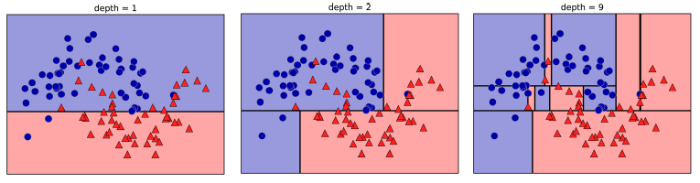
Figure 10 Decision boundary of tree with depth 1, 2, 9

This recursive process yields a binary tree of decisions, with each node containing a test. The recursive partitioning of the data is repeated until each region in the partition (each leaf in the decision tree) only contains a single target value (a single class or a single regression value). A leaf of the tree that contains data points that all share the same target value is called pure.
Typically, building a tree as described here and continuing until all leaves are pure leads to models that are very complex and highly over fit to the training data.
There are two common strategies to prevent overfitting: stopping the creation of the tree early (also called pre-pruning), or building the tree but then removing or collapsing nodes that contain little information (also called post-pruning or just pruning).
Feature importance in trees: - Instead of looking at the whole tree, which can be taxing, there are some useful properties we can derive to summarize the workings of the tree. The most commonly used summary is feature importance, which rates how important each feature is for the decision a tree makes. It is a number between 0 and 1 for each feature, where 0 means “not used at all” and 1 means “perfectly predicts the target.”

Random forests
Ensembles are methods that combine multiple machine learning models to create more powerful models. There are two ensemble models that have proven to be effective on a wide range of datasets for classification and regression, both of which use decision trees as their building blocks: random forests and gradient boosted decision trees.

As we just observed, a main drawback of decision trees is that they tend to over fit the training data. Random forests are one way to address this problem. A random forest is essentially a collection of decision trees, where each tree is slightly different from the others. If we build many trees, all of which work well and over fit in different ways, we can reduce the amount of overfitting by averaging their results. This reduction in overfitting, while retaining the predictive power of the trees.
Figure 11 Decision boundaries found by five randomized decision trees and the decision boundary obtained by averaging their predicted probabilities
As you can see, the random forest gives nonzero importance to many more features than the single tree. The randomness in building the random forest forces the algorithm to consider many possible explanations, the result being that the random forest captures a much broader picture of the data than a single tree.

Support vector machines
Support vector machines (SVMs) is a set of supervised learning methods used for classification, regression. With this algorithm, we plot each data item as a point in n-dimensional space with the value of each feature being the value of a particular coordinate. Then, we perform classification by finding the hyper-plane that differentiates the two classes.
Figure 12 Decision boundary found by a linear SVM
Now let’s expand the set of input features, say by also adding feature1 ** 2, the square of the second feature, as a new feature. Instead of representing each data point as a two-dimensional point, (feature0, feature1), we now represent it as a three dimensional point, (feature0, feature1, feature1 ** 2).
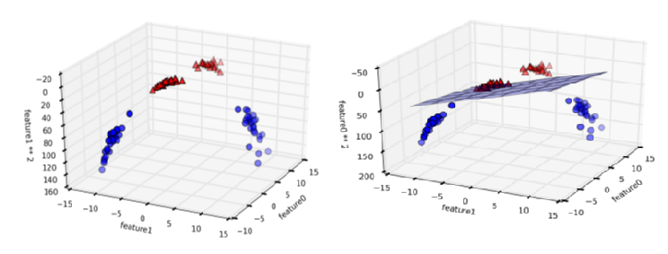
Figure 13 Expansion of the dataset, created by adding a third feature derived from feature 1 and Decision boundary found by a linear SVM on the expanded three dimensional dataset
In the new representation of the data, it is now indeed possible to separate the two classes using a linear model, a plane in three dimensions.

Model Evaluation

Regression Model Evaluation
- R2 Score:
R^2 (coefficient of determination) regression score function. The best possible score can be 1 and it can go negative as well in worst conditions.
- Mean squared error:
The mean squared error function computes mean square error, a risk metric corresponding to the expected value of the squared error or loss.
- Mean absolute error:
The mean absolute error function computes mean absolute error, a risk metric corresponding to the expected value of the absolute error loss. Here is a code example which demonstrates the usage of various evaluation methods for regression models.

Classification model evaluation
- Accuracy score:
The accuracy score function computes the accuracy, either the fraction (default) or the count of correct predictions. If the entire set of predicted labels strictly match with the true set of labels, then the subset accuracy is 1.0; otherwise it is 0.
$$Accuracy=\frac{TP}{\begin{aligned}\left(TP+FP+TN+FN\right) \\ \end{aligned}}$$
- Precision Score:
The precision is the ratio tp / (tp + fp) where tp is the number of true positives and fp the number of false positives. The precision is intuitively the ability of the classifier not to label as positive a sample that is negative.
$$Precision=\frac{TP}{\begin{aligned}\left(TP+FP\right) \\ \end{aligned}}$$
- Recall Score:
The recall is the ratio tp / (tp + fn) where tp is the number of true positives and fn the number of false negatives. The recall is intuitively the ability of the classifier to find all the positive samples.
$$Recall=\frac{TP}{\begin{aligned}\left(TP+FN\right) \\ \end{aligned}}$$
- F1 Score:
The F1 score can be interpreted as a weighted average of the precision and recall, where F1 score reaches its best value at 1 and worst score at 0.
- Classification report:
Builds a report containing main classification metrics.
- Confusion matrix:

Literature survey

Vehicle health characteristics
It is hard to diagnose failure in advance in the vehicle industry because of the limited availability of sensors and some of the designing exertions. It looks feasible today to analyze sensor’s data along with machine learning techniques for failure prediction. In this article, an approach is presented for fault prediction of four main subsystems of vehicle, fuel system, ignition system, exhaust system, and cooling system. Sensor is collected when vehicle is on the move, both in faulty condition (when any failure in specific system has occurred) and in normal condition. The data is transmitted to the server which analyzes the data. Interesting patterns are learned using four classifiers, Decision Tree, Support Vector Machine, K Nearest Neighbor, and Random Forest. These patterns are later used to detect future failures in other vehicles which show the similar behavior. Accuracy comparison of all classifiers is performed on the basis of Receiver Operating Characteristics (ROC) curves.
Vehicle systems are complex both in hardware and software so their maintenance is challenging and that too predictive maintenance is difficult in predictive maintenance, current condition of system/vehicle is analyzed to predict what is probably going to fail. OBD sensor is used to get the sensor data required for the analysis. On- Board Diagnostic (OBD) frameworks give the vehicle owner or a repair professional access to condition of current data.
Block diagram
An OBD2 scanner is connected with the vehicle through OBD2 port. This scanner behaves like a bridge between vehicle and portable device, that is mobile and laptop which supports Bluetooth. Data is continuously being generated and transmitted to smart phone via Bluetooth.
First step is feature selection in which data stream of DTC is filtered in feature selection process using expert’s suggestion. Then a PCA (Principle Component Analysis) is applied on data set for feature reduction. After that four classification algorithms are used in classification phase including Decision Tree, Random Forest, K-NN, and SVM. These results are stored on server for further derivation which is used for fault detection and remote monitoring of the vehicle.
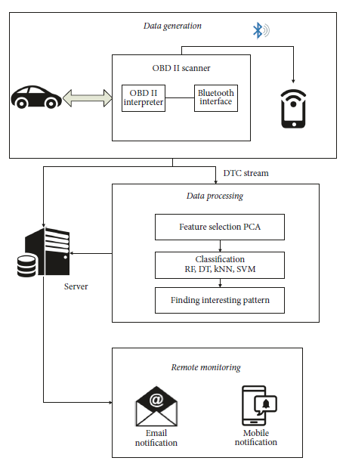
Figure 14 VMMS Architecture
The performance of each algorithm on particular system is evaluated on the basis of accuracy, precision, recall and F1 score.
Our first contribution to this paper is data generation and feature selection. We selected those distinctive sensors that can cause a system to break down. The second contribution is to propose a user friendly vehicle fault prediction and vehicle remote health monitoring system. [1]
The competitive businesses' desire to provide "smart services" and the pace at which the modern automobiles are increasing in complexity, are motivating the development of automated intelligent vehicle health management systems. Current On-Board Diagnosis (OBD 11) systems use simple rules and maps to perform diagnosis. On-Board Diagnostic (OBDII) systems perform a great job in assisting technicians to trouble-shoot faulty components in the vehicle.
Fault detection and diagnosis (FDD) has mainly evolved upon three major paradigms, viz., model- based, data-driven and knowledge-based approaches. A data driven approach can provide a more systematic solution if monitored sensor data is available over a period of time for analysis.
We propose a data mining approach that utilizes the knowledge from signal-processing, statistical and pattern recognition domains. In this paper, we show its applicability to FDD in a real automotive engine, and comment on its practical application. The engine is operated under various scenarios, and the data is collected for FDD analysis.
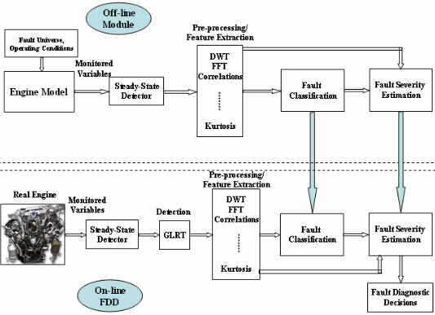
Figure 15 Generic data driven FDD approach
Above figure depicts our proposed approach for automatically detecting and diagnosing faults in automotive engines. It is a generic approach applicable to any engineering system, it requires only sensor data, and does not need detailed system models. The collected data is processed and analyzed to achieve good diagnostic accuracy.
Fault classification - Test design plays a critical role in achieving better classification accuracy. Here, the tests are designed to uniquely detect pre-defined faults, and generate a D-matrix (Diagnostic matrix) for on-line inference. We need a testing strategy to classify the faults into pre-defined classes. Generalized likelihood ratio test (GLRT), cumulative sum (CUSUM), etc., are used to detect the abnormal events. Principal Component Analysis (PCA) is an excellent tool to cluster the data into different regions.
In this paper, we proposed a systematic data- driven approach for performing fault detection and diagnosis in automotive engines and showed its applicability to Toyota Camry engine. Pre- and post - fault data is collected from the engine under various scenarios, and the proposed approach is applied to generate a D-matrix to uniquely isolate the faults into pre-defined fault classes [2]

Driving characteristics
Input = OBD2 scanner data, acceleration data, breaking data
Processing = ML algorithm (classification)
Output = Classifying whether driver’s driving is reckless or not
The characterization of driving behavior is not only crucial for accident prevention, as most of car accidents are due to human mishandling , but it is also important for designing driving models, which are the core of algorithms that might make the future of self-driving cars possible.
Cars can nowadays record several thousands of signals through the CAN bus technology and potentially provide real-time information on the car. It can record the data gas pedal position, brake pedal pressure, steering wheel angle, steering wheel momentum, velocity, RPM, frontal and lateral acceleration. We propose an unsupervised learning technique that clusters drivers in different groups.
Data collection- For determining driving behavior data we can analyze is Brake pedal pressure (BRK), Gas pedal position (GAS), Revolutions per minute (R.P.M.), Speed (SPD), Steering wheel angle (S.W.A.), Steering wheel momentum (S.W.M.), Frontal acceleration (F. ACC.), Lateral acceleration (L. ACC.)
These signals are directly or, in some cases, indirectly related to the interaction between the driver and the vehicle.
Feature extraction: - From each considered signals we extract the following 7 indicators
Values of the signal for each sample, Difference quotient (discrete first derivative), Time interval between two singular points, Values of the local maxima, moving mean, moving median, moving standard deviation.
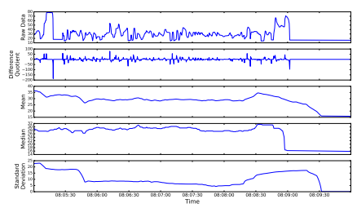
Figure 16 gas pedal angle signal and its difference quotient, mean, median, and standard deviation.
Once the full dataset is collected, we use the K-means clustering algorithm to leverage the features defined in the previous section with the aim of grouping drivers upon common similarities. In order to plot them on bi-dimensional space, therefore, a dimensionality reduction technique has to be performed. In this work we use Principal Component Analysis (PCA), a well-known statistical procedure that decreases the dimensionality of a space projecting it into another one whose dimensions (principal components) are orthogonal to each other and such that the variance of the projected data-points on the principal components is maximized. [3]

The purpose of such an endeavor is to classify the drivers according to their risk-proneness within the larger context of increasing traffic safety, which is a major concern worldwide. Cluster and principal component analyses from exploratory statistics have been used to identify and explain drivers grouping according to their driving behavior.

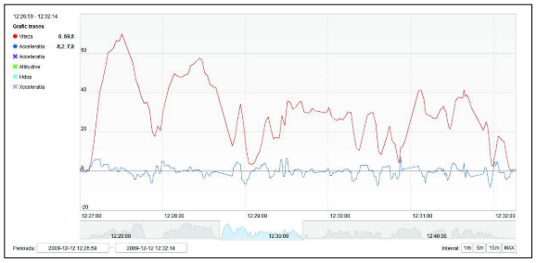
Figure 17 Speed and acceleration plot over time
For the statistical analysis, following driving parameters extracted from the raw data:
Speed over 60 km/h: percent of time (V60)
Speed: mean value (Vmn) and standard deviation (Vsd)
Acceleration: standard deviation (Asd) –
Positive acceleration: mean value (A+mn) and standard deviation (A+sd) –
Braking: mean value (Brmn) and standard deviation (Brsd)
Mechanical work (w)
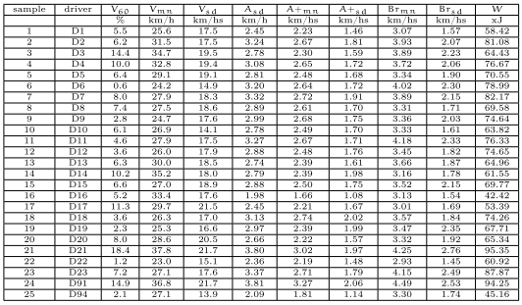
Figure 18 Table showing the driving characteristics

Principal Component Analysis is a statistical method for arranging large arrays of data into interpretable patterning match. It transforms a number of (possibly) correlated variables into a (smaller) number of uncorrelated variables called principal components.
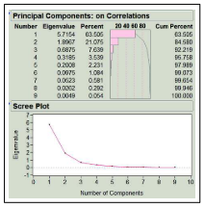
Figure 19 Principal Component Analysis on dataset

Data Interpretation: - Based on the analysis of the principal components and of their values and correlations to the clusters, we can derive an interpretation.
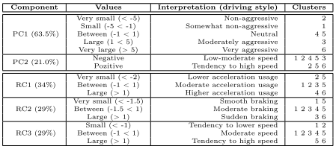
Figure 20 Interpretation by principal components and by rotated components
[4]

Pothole and speed breaker detection
Input: - acceleration, gyroscopic data, accelerometer, camera
Processing: - Acceleration and image captured undergo the algorithm in our framework to detect if there is any road anomaly is there
Output: - It will detect pothole/ speed breaker, then the driver will slow down the vehicle. Also, it will keep mark where pothole was detected and send the data to respective authority.

It is essential to identify pothole and humps in order to avoid accidents and damages to the vehicles that is caused because of distress to drivers and also to save fuel consumption. In this regard, this work presents a simple solution to detect potholes and humps and hence avoid accidents and help driver. And also in assisting in self driving for cars.
Potholes and humps are detected using ultrasonic sensors and their information like location is provided to the authorities with the help of GPS and GSM and alerts the driver regarding the bumpy roads and potholes on its path. With this information the authorities could take measures to repair the roads which in turn help to avoid accidents caused due to nontechnical humps and hence lower the percentage of damaged roads and avoid road accidents. [5]
Potholes are detected using Image Processing Technique and Ultrasonic Sensors are used to detect humps. Use of ultrasonic sensors to detect the speed breakers, it works on principle that transmitter triggers the frequency from transmitter and the receiver will wait for the wave to return. The wave returns after getting reflected by any object. If there is a speed breaker on the road, waves will return sooner than usual and alarm will be triggered.
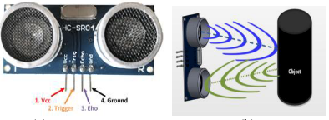
Figure 21 Ultrasonic sensor and receive-transmit operation
Pothole detection: - The camera captures the image of the road continuously through Open CV in RGB form. Then it converts the image from RGB form to HSV by image processing technique. It is then dilated for image enhancement of the concentrated region. The obtained image is then compared with the stored pothole reference image in the database. If, the captured image matches with stored image, then the Raspberry Pi sends the location of the pothole to the municipal officials through E-mail along with the captured image.
The location can also be saved and shared in the test tool. It also generates alert to the driver through LCD display and speaker that a pothole is detected. This process is repeated.

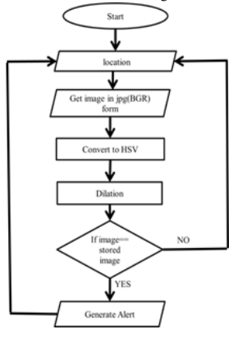
Figure 22 Flowchart for pothole detection
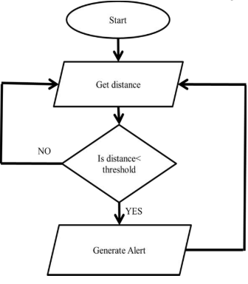 [5]
Figure 23 Flow chart for speed breaker detection

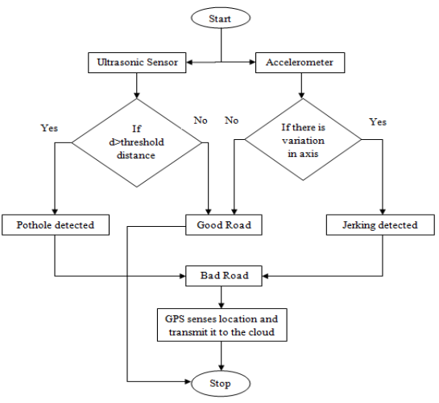 [6]
Figure 24 complete flowchart of detection
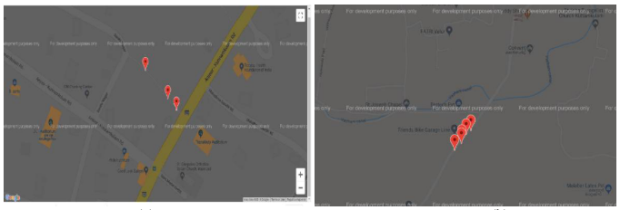
Figure 25 Location of potholes plotted in map [6]
While comparing both, figure (a) shows less number of potholes and figure (b) shows more number of potholes. The user can identify the better roads from this. The authority can also do the maintenance of roads which have pathetic conditions.

The location of these potholes would be available on a centrally hosted map which can be accessed by both end users and civic authorities. So that, next time while selecting the route end user will also see the factor how many potholes are there on his/her route.
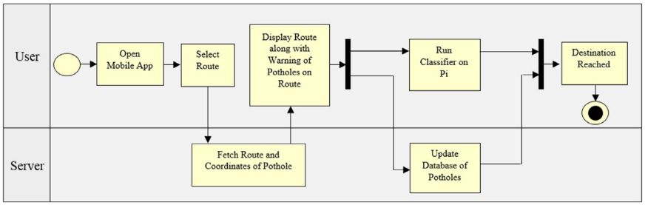
Figure 26 System model of deepbus [7]
User can find routes with information about potholes and selects the best route for destination by running the classifier on Raspberry Pi. The overall process is divided into three main phases:
- Data Collection and Preprocessing: Using the sensors available to collect data on road information. This will involve manually labelling timestamps with presence of potholes and bumps. This can be done by using a smartphone or a Raspberry Pi with appropriate sensors. After data is collected, it will need to be preprocessed which includes removal of missing data, outlier detection, grouping data etc. It is to be noted that the suspension, steering, braking, acceleration of all vehicles are different. So, it is possible but not necessary that multiple models will have to be trained in the future for different vehicles. For our domain, we have done this research work on a single vehicle.
- Training: Training various machine learning models on the obtained datasets. This poses questions like which model will help us achieve the best Accuracy, and least False Positive and False Negative rate.
- Classification/Testing: After the first two phases, the model is deployed on phones and collects data from the smart- phone sensors in real time and classify the presence of a pothole/bump. Misclassifications can be minimized by methods like Weighted Polling, Majority Voting etc. The locations will then be marked on a centrally hosted map which will be available to all users.
After running a script on the raw data, we obtained the final dataset which was in .csv format with the following eight columns: [Time, Ax, Ay, Az, Gx, Gy, Gz, Pothole]. Label 1 denotes “pothole” and label 0 denotes “no pothole”
This dataset will undergo the classification algorithm to detect, whether it is pothole or not.
We have compared the performance of various machine learning models (Logistic Regression, Support Vector Machine (SVM), K-Nearest Neighbors (KNN), Naive Bayes, Decision Tree, Random Forest and Ensemble Voting) based on different parameters (Accuracy, F-score, Precision and Recall) and identified that Random Forest is the best model for pothole detection.
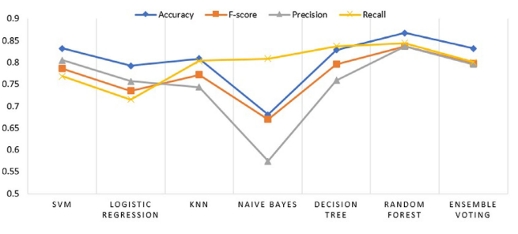
Figure 27 Performance comparison of various machine learning algorithms [7]
We can approach pothole detection problem by approach of image processing for the detecting and positioning of potholes on roadways. Several edge detection and machine learning algorithms such as Canny edge and K-means have been tested and implemented on images to render satisfactory results. However, image-based pothole detection methods suffer from challenges such as obstructions, quality of cameras used and varying conditions of light that result in shadows. These drawbacks often cause inaccuracy of results leading to false positives or false negatives.
This paper proposes a low-cost hardware setup that combines low-computational accelerometer data-based method and high-computational image-based approach. The system would be a low-cost implementation as it would make use of a smartphone and an OBD-II. The two approaches combined would increase the accuracy and efficiency of the system when compared their independent implementation.
The proposed method focuses on a low-cost option and reuse of existing hardware resources, it utilizes smartphone and OBD II module. The method can be called a low-cost implementation as it makes use of minimal hardware components. The role of the smartphone in this implementation with an inbuilt IMU is to provide visual data, as well as an integrated dataset that involves accelerometer data and other vehicle parameters obtained from the OBD-II module.
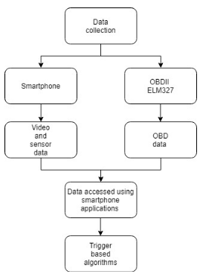
Figure 28 Flowchart of data acquisition
The vehicle used for data acquisition are swift desire (2019) and XUV 500 (2013). The data is recorded at 1Hz sampling rate. The vehicle is stationary for 30 seconds in order to acquire idling conditions. Datasets have been collected for different durations of time mostly at an interval of 20-30 minutes, accessed through a mobile application to gather OBDII data (Torque Pro).
The data captured by the Tri-axial accelerometer is filtered using a high-pass filter to eliminate vehicular vibrations and noise. The flow chart of the method is shown in figure 3. The filter function consists of a low-pass filter which is then converted into a high-pass filter by the means of spectral inversion. The output is then convoluted with the accelerometer signal to obtain only a band of high frequency signal from the data. As a part of the preliminary approach, the Z-Thresh method has been implemented. The Z-Thresh algorithm confirms that peak acceleration in the vertical axis (X-axis) is a prime characteristic that determines anomalies such as potholes on roads.
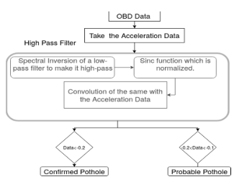
Figure 29 Flowchart of low-computational data-based trigger.
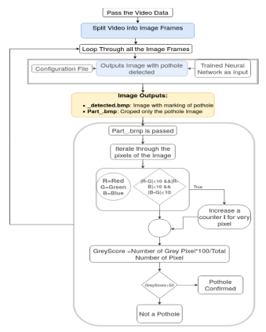
Figure 30 Flowchart of high-computational image-based trigger
The result of the image-based trigger approach positively validates potholes encountered by the vehicle. The algorithm is expected to detect potholes using the R- CNN method. The result also displays several parameters such as vehicle speed and accelerometer data at the location. The matched time frame is extracted, and thresholding methods are implemented on the corresponding accelerometer data.
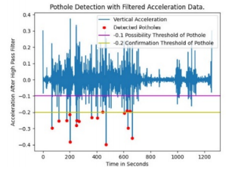
Figure 31 Pothole validation through accelerometer data
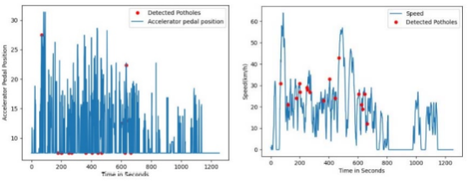
Figure 32 Accelerator pedal position and vehicle speed through potholes
The data undergoes filtering and thresholding methods to render negative peaks where the vehicle encounters the pothole. This data can be considered to validate the results acquired by the visual data. This method can be regarded as the image triggered method.
The trigger-based approach also imposed a few drawbacks, Shadows caused by trees and buildings impose false positives that act as a trigger which will be further investigated using accelerometer data. [8]
Integration of several image- processing schemes has been used to produce an algorithm using Python Language from the OpenCV library that can detect and report potholes automatically from a moving vehicle. With a rate of about 8 frames per second, images were processed per frame to detect potholes by analyzing its color, depth, and area. With cars rapidly getting “smarter”, sophisticated sensors are installed allowing the vehicle to profile the road surface under the wheels and identify different road distresses.
However, vehicles are still vulnerable to damages caused by these road distresses like bumps, patches, and especially Potholes. Existing pothole detection can be categorized into three methods: vibration-based method, 3D reconstruction-based methods, and vison-based methods. To date, most automotive technology engineers have turned their implementations of a camera-based installations, which provide visual effects and movement recognition.
The system should be able to detect potholes and send report to the main server that includes the image and the location of the pothole. A unit that was installed in the vehicle with camera module, GPS system, and three LEDs that would act as indicators if the device was turned on, if a pothole was detected, and if the report was sent. The camera module was placed securely in the upper portion of the car, behind the rear mirror, to obtain a good range and to acquire reliable and accurate results. For the pothole detection, the camera module would capture eight images per second in front of the windscreen of the car.
Image-processing is done by first removing other objects in the image such as the sidewalks and the pedestrian, the algorithm would extract first the pavement or the road itself and the extracted image would be the only part that would undergo the main process. Potholes then would be detected based on its color and area using Canny edge detection, and finally contour detection and final filtering.
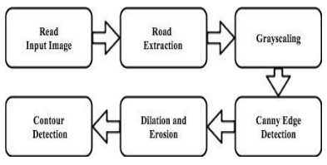
Figure 33 Image processing system
Another key element of the system is the automatic reporting system. If a pothole was detected, the same microcomputer would connect to the Internet to send the image and the location of the said pothole to the main database. Once the system is powered on, the camera would start to capture images in front of the moving car. The microcomputer processes the captured images and analyzes it through image processing. Once detected, the microcomputer connects to the GPS module to acquire the location of the occurrence of the pothole.
The system has two testing set-ups namely, ideal and non-ideal. The ideal set-up included areas that have no other vehicles nearby and do not have other objects, such as trashes, rocks, other road distresses, and even no pedestrians showing in the camera. The non-ideal set-up is a set-up constituted in a normal driving condition.
Accuracy, sensitivity, specificity are the parameters calculated using data we got from tests to check the accuracy and reliability of the system. Response time is also recorded to measure the fast processing of system. [9]
The paper is describing a mobile sensing system for road irregularity detection using Android OS based smart-phones. Selected data processing algorithms are discussed and their evaluation presented with true positive rate as high as 90% using real world data. The optimal parameters for the algorithms are determined.
Pothole detection algorithm is based on simple machine-learning approach using X and Z axis acceleration and the vehicle velocity data as input. The algorithm consists of five consecutive filters: speed, high-pass, z-peak, xz-ratio and speed vs. z ratio. Simple threshold based algorithms such as z-sus, z-peak etc. undoubtedly are suitable for implementation on Android based smart-phones.
The technical requirements for the system are 1) the system should be able to detect events potholes in real time, 2) System should be able to detect events while driving in different four-wheel vehicle types such as passenger cars, minivans and buses.
Analog Devices 3-axis accelerometer ADXL335 is used to record acceleration of vehicle. Mans OS based software was used for raw acceleration data acquisition (sampling rate 100Hz) and transmission through USB interface to a laptop computer. After the acquisition of the first test data set, a search for potential event related features was performed.
Some algorithms to detect potholes: -
- Pothole detection algorithm Z-THRESH: - Events are represented by measurements with values exceeding specified threshold levels.
- Pothole detection algorithm Z-DIFF: - Events are represented by consecutive measurements with difference value above specific threshold level.
- Pothole detection algorithm STDEV (Z): -Events are represented by measurements with standard deviation value above specific threshold level.
- Pothole detection algorithm G-ZERO. Events are represented by tuple of measurements with all three axis values below specific threshold level.
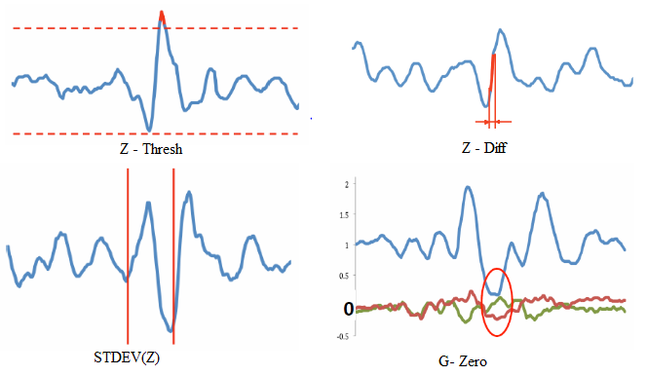
Figure 34 Pothole detection algorithms
This paper describes accelerometer data based pothole detection algorithms for deployment on devices with limited hardware/software resources and their evaluation on real world data acquired using different Android OS based smart-phones. [10]

References
[1] U. Shafi, A. Safi, A. R. Shahid, S. Ziauddin, and M. Q. Saleem, “Vehicle remote health monitoring and prognostic maintenance system,” J. Adv. Transp., vol. 2018, 2018, doi: 10.1155/2018/8061514.
[2] S. M. Namburu, M. Wilcutts, S. Chigusa, L. Qiao, K. Choi, and K. Pattipati, “Systematic data-driven approach to real-time fault detection and diagnosis in automotive engines,” AUTOTESTCON (Proceedings), pp. 59–65, 2006, doi: 10.1109/AUTEST.2006.283654.
[3] U. Fugiglando et al., “Driving Behavior Analysis through CAN Bus Data in an Uncontrolled Environment,” IEEE Trans. Intell. Transp. Syst., vol. 20, no. 2, pp. 737–748, 2019, doi: 10.1109/TITS.2018.2836308.
[4] Z. Constantinescu, C. Marinoiu, and M. Vladoiu, “Driving style analysis using data mining techniques,” Int. J. Comput. Commun. Control, vol. 5, no. 5, pp. 654–663, 2010, doi: 10.15837/ijccc.2010.5.2221.
[5] B. G. Shivaleelavathi, V. Yatnalli, Chinmayi, V. S. Yamini, and S. Thotad, “Design and development of an intelligent system for pothole and hump identification on roads,” Int. J. Recent Technol. Eng., vol. 8, no. 3, pp. 5294–5300, 2019, doi: 10.35940/ijrte.C5936.098319.
[6] A. Terish, S. J. T. D, S. Valsan, P. Sooraj, and N. V Indrasena, “Real Time Pothole Detection and Road Monitoring Sysytem,” pp. 6740–6744, 2019, doi: 10.15680/IJIRSET.2019.0806034.
[7] K. Bansal, K. Mittal, G. Ahuja, A. Singh, and S. S. Gill, “ DeepBus : Machine learning based real time pothole detection system for smart transportation using IoT ,” Internet Technol. Lett., vol. 3, no. 3, pp. 2–7, 2020, doi: 10.1002/itl2.156.
[8] K. S. Ashwini, G. Bhagwat, T. Sharma, and P. S. Pagala, “Trigger-Based Pothole Detection Using Smartphone and OBD-II,” Proc. CONECCT 2020 - 6th IEEE Int. Conf. Electron. Comput. Commun. Technol., 2020, doi: 10.1109/CONECCT50063.2020.9198602.
[9] M. M. Garcillanosa, J. M. L. Pacheco, R. E. Reyes, and J. J. P. San Juan, “Smart Detection and Reporting of Potholes via Image-Processing using Raspberry-Pi Microcontroller,” 2018 10th Int. Conf. Knowl. Smart Technol. Cybern. Next Decad. KST 2018, pp. 191–195, 2018, doi: 10.1109/KST.2018.8426203.
[10] A. Mednis, G. Strazdins, and R. Zviedris, “Real Time Pothole Detection using Android Smartphones with Accelerometers • Road infrastructure as blood vessels,” 2011.

Appendix A
Weekly report
Domain: - AI and ML learning tools
Sr. No | Tech tools | Description | Deadline | Status
1 | AI and Machine learning tools ( Udemy course) | Unsupervised model – clustering model | 6/4/21 | In - process
2 | Literature survey | Reviewing and implementing the process they used to decide what process we should follow | 16/4/21

Process:-
Sr. No | Tech tools | Description | Deadline | Status
1 | GIT | Day 1 course |  | Completed
 |  | Week 1 course |  | Completed
2 | Word | TOC/TOF/ reference |  | Completed
3 | Mendeley | Account open, group create, use to add reference in report |  | Completed

Tech and tools:-
Sr. No | Tech tools | Description | Deadline | Status
1 | Pycharm | Download and practice python code in it. |  | Completed
2 | Sololearn Python | Practice classes and complete regular expression |  | Completed
3 | Pep8 | Practice Pep8 on code |  | Completed
4 | Low code platform(pycaret) | Practice pycaret library on unsupervised model | 14/4/21
5 | Kaggle | Practice pycaret library on one of the data set from kaggle | 14/4/21

